Flexmold Controller

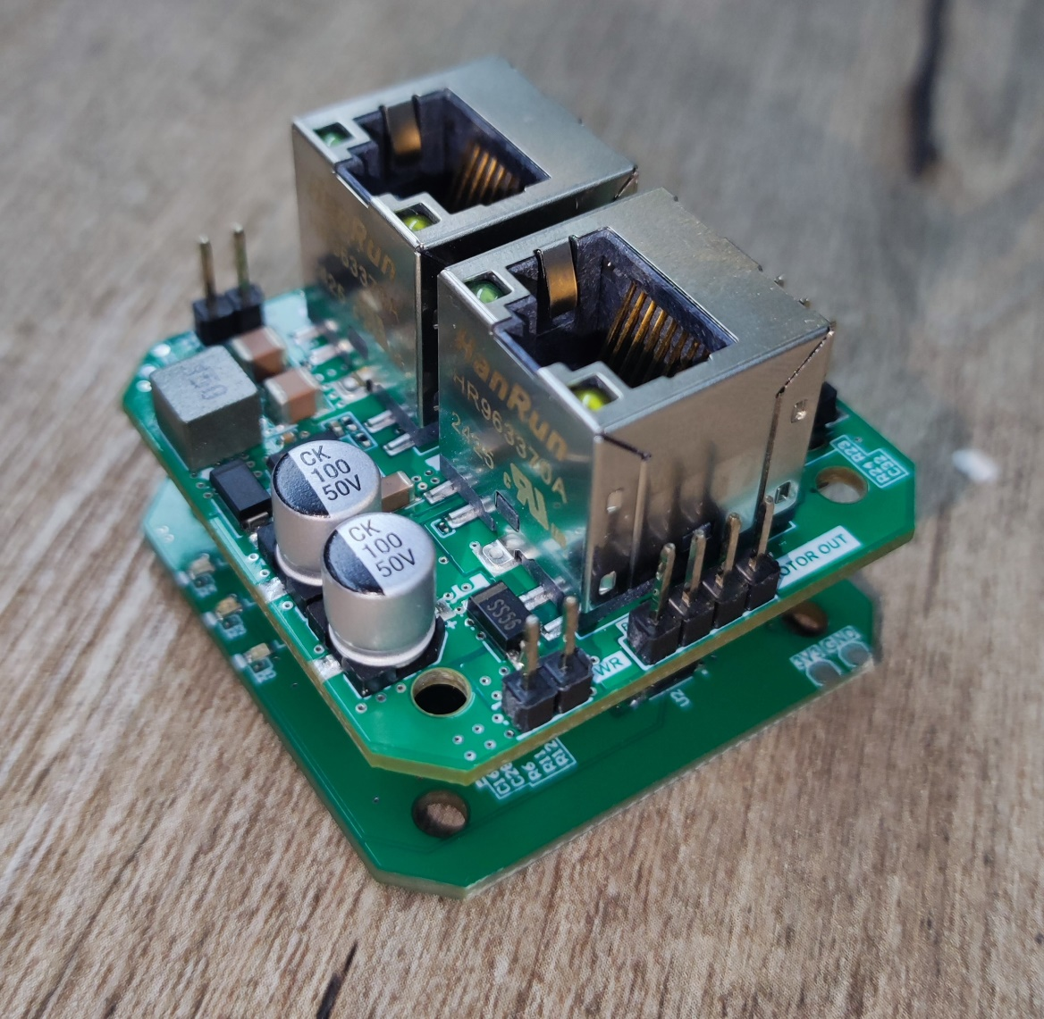

Safety Statement

Assembling machine components like power supplies, motors or other electrical components involves dealing with high voltages which can be dangerous and needs high attention to detail, experience, knowledge of software, electricity and electro-mechanics or mechanics.
This device is driven by DC power supply, make sure the power positive and negative rails go in the correct pins. Do not mix conductive foreign matter such as screws or metal, keep it dry and in a moisture proof environment.
BEFORE MAKING ANY CONNECTIONS OR DISCONNECTIONS POWER MUST BE REMOVED FROM THE DEVICE.

Introduction
The Flexmold Controller is an industrial EtherCAT based two-phase stepper motor driver. It supports speed and direction control interface. The device embeds TMC2160 high voltage stepper motor driver with a LAN9255 EtherCAT Device with integrated Cortex M4F Microcontroller. The device features a smaller form factor which can be mounted on the stepper motor itself. Despite a smaller form-factor the device printed circuit board is designed to draw heat out of the IC and MOSFETs.

Features
- Can operate over a wide operating voltage range 16V – 36V.
- Easily operate without heat sink with up to 1.2A peak current per coil.
- Power reverse polarity protection.
- Over-heat, over-current and short circuit protection.
- TVS and ESD protection embedded.

Electrical Specification
Voltage | 16 – 36V
Motor Type | Two-Phase Stepper Motor
Motor Driver | TMC2160
Motor Current | Without Heatsink: 1.2A peak current - With Heatsink: 2.5A peak current
Controller | LAN9255 (Integrated SAM E53 MCU and LAN9253)
Other Outputs | 1 x DC Pump support having current rating of 1A.
Dimensions | 42.3 x 42.3 x 34.4 mm (overall with both PCB stacked)
Operating Temperature | -20°C to +80°C
Heat Sink Size | 18 x 14 x 6 mm (Link)

Product Images

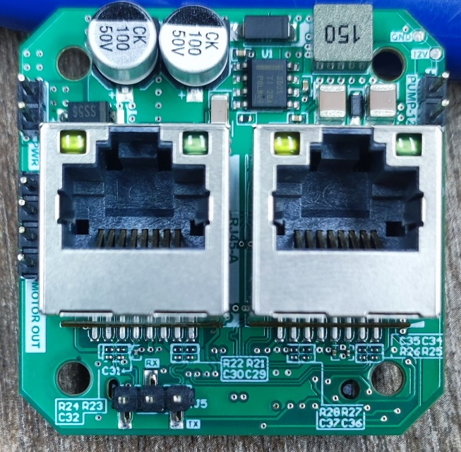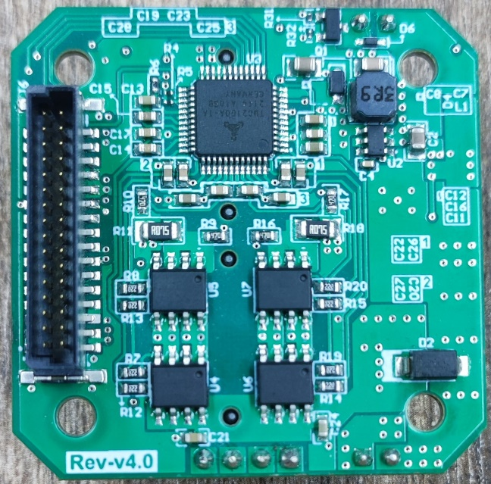
Pic: Top Board - top side on the left and bottom side on the right

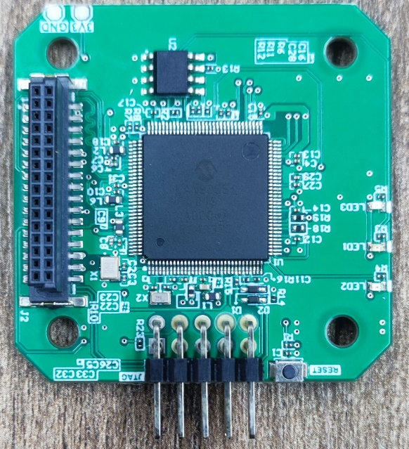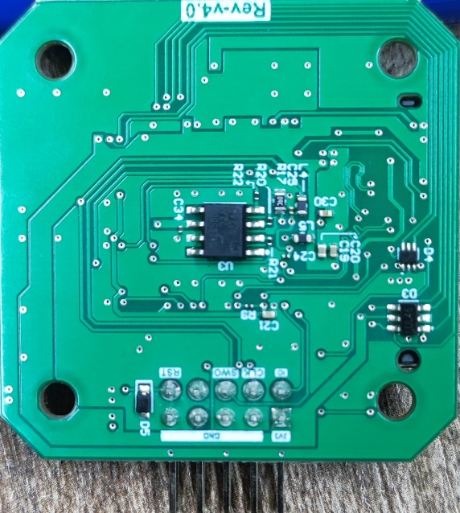
Pic: Bottom Board - top side on the left and bottom side on the right

Programming Interface

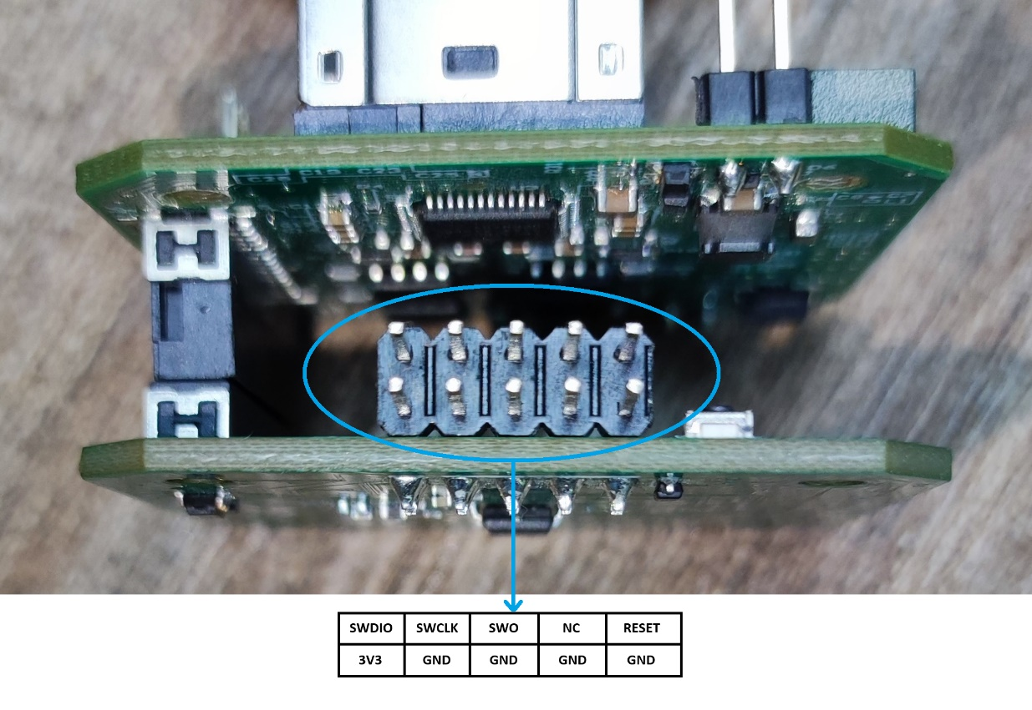
Wiring
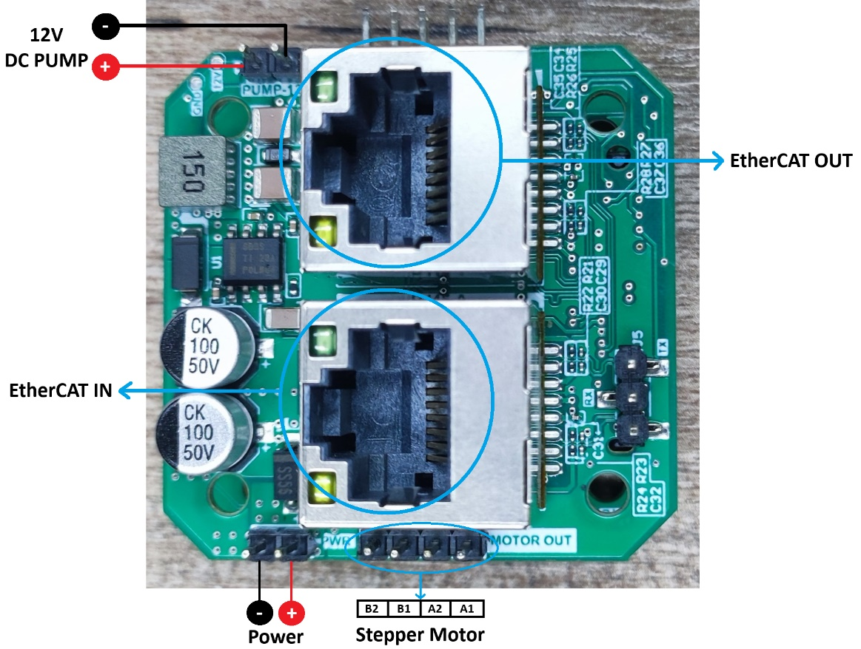
Dimensions

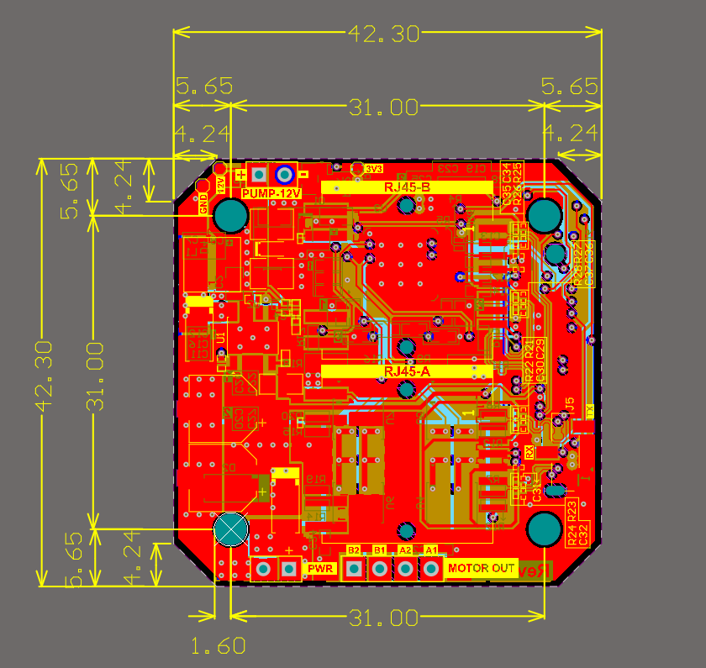
Pic: Top Board

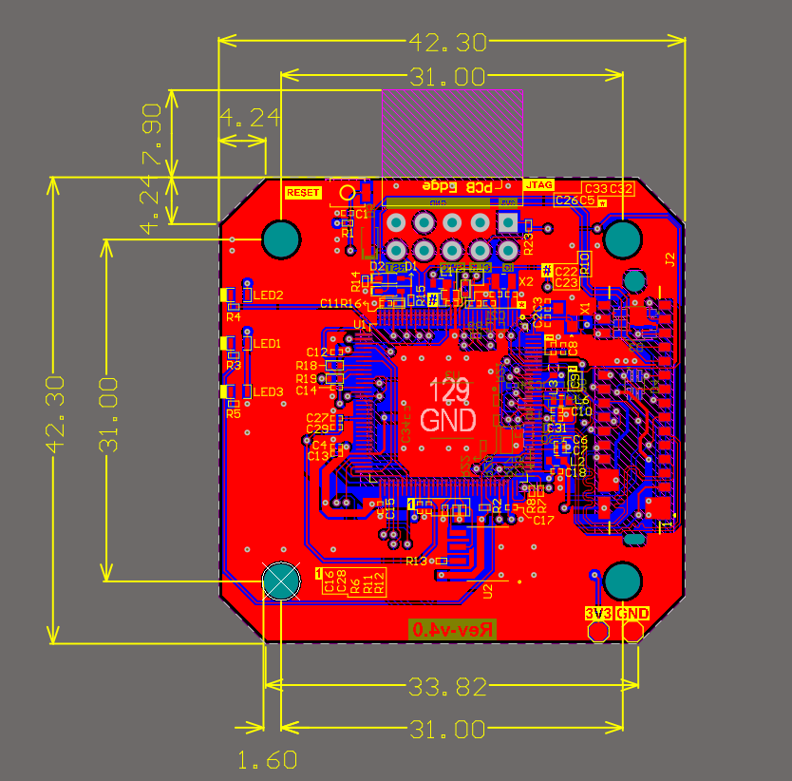
Pic: Bottom Board
Heat Sink Dimensions

